1. **INTRODUCTION**

## Project Overview

HepaCare is an AI-powered web application designed to classify various types of liver

grains using deep learning techniques, particularly Transfer Learning. The project leverages a pre-trained Convolutional Neural Network (CNN) model to accurately identify patient clinical

varieties from images uploaded by the user.

This solution bridges the gap between medical practices and modern AI by offering an intuitive platform that automates liver variety classification, replacing traditional manual

methods that are often time-consuming and error-prone. The system is implemented using Python, TensorFlow/Keras for the backend model, and Flask for the web interface, providing an end-to-end pipeline from image input to class prediction.

## Purpose

The purpose of HepaCare is to:

* + - Provide an accessible and intelligent platform for liver cirrhosis prediction that benefits patients, distributors, exporters, food laboratories, and quality control units.
    - Minimize manual effort and errors in the grain identification process through automation.
    - Enhance decision-making for liver sorting, packaging, and distribution based on liver condition.
    - Reduce dependency on expensive lab analysis by introducing a low-cost, AI-based tool.
    - Encourage digital transformation in healthcare, particularly in quality inspection and post-harvest processing.

By addressing the practical challenges in patient clinical identification, this application contributes to both efficiency and accuracy, ultimately supporting the larger goal of precision

healthcare.

1. **Ideation Phase**

## Define the Problem Statements

|  |  |
| --- | --- |
| Date | 30 june 2025 |
| Team ID | LTVIP2025TMID35183 |
| Project Name | Revolutionizing Liver Care : Predicting Liver Cirrhosis using Advanced Machine Learning Techniques |
| Maximum Marks | 2 Marks |

**Customer Problem Statement Template:**

Create a problem statement to understand your customer's point of view. The Customer Problem Statement template helps you focus on what matters to create experiences people will love.

A well-articulated customer problem statement allows you and your team to find the ideal solution for the challenges your customers face. Throughout the process, you’ll also be able to empathize with your customers, which helps you better understand how they perceive your product or service.

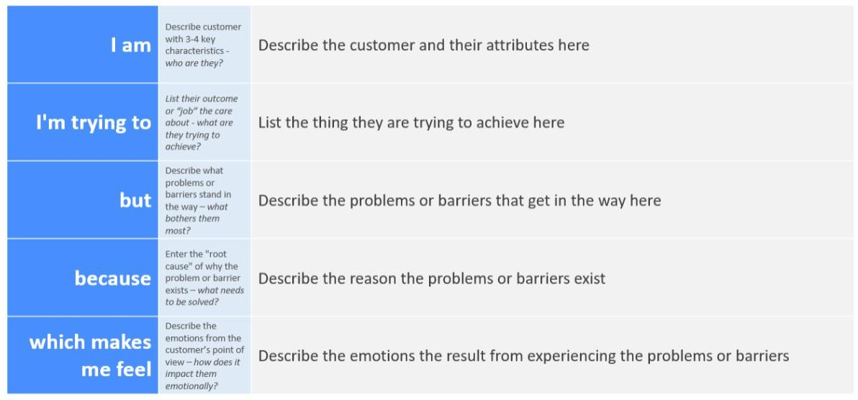

Reference: <https://miro.com/templates/customer-problem-statement/>

**Example:**

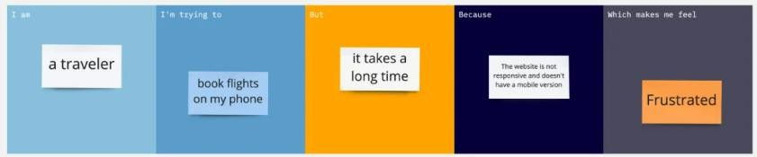

|  |  |  |  |  |  |
| --- | --- | --- | --- | --- | --- |
| **Problem**  **Statement (PS)** | **I am**  **(Customer)** | **I’m trying to** | **But** | **Because** | **Which makes me feel** |
| PS-1 | A rice farmer from a rural village | identify the ty cultivation | p I don’t see e of rice  have  access to lab testing or expert identificat  ion | it’s  ds I have befor expensive  and not locally available | confused, uncertain, e  and worried about crop  planning |
| PS-2 | An agricultural extension officer or researcher | quickly identify and classify different rice types in the field | manual classificat ion is time- consumin g and not always  accurate | grain types look visually similar to the naked eye | frustrated and slows down data collection and analysis |

**2. Ideation Phase**

## Empathize & Discover

|  |  |
| --- | --- |
| Date | 30 june 2025 |
| Team ID | LTVIP2025TMID35183 |
| Project Name | Revolutionizing Liver Care : Predicting Liver Cirrhosis using Advanced Machine Learning Techniques |
| Maximum Marks | 4 Marks |

**Empathy Map Canvas:**

An empathy map is a simple, easy-to-digest visual that captures knowledge about a user’s

behaviours and attitudes.

It is a useful tool to helps teams better understand their users.

Creating an effective solution requires understanding the true problem and the person who is experiencing it. The exercise of creating the map helps participants consider things from the user’s perspective along with his or her goals and challenges.

**Example:**

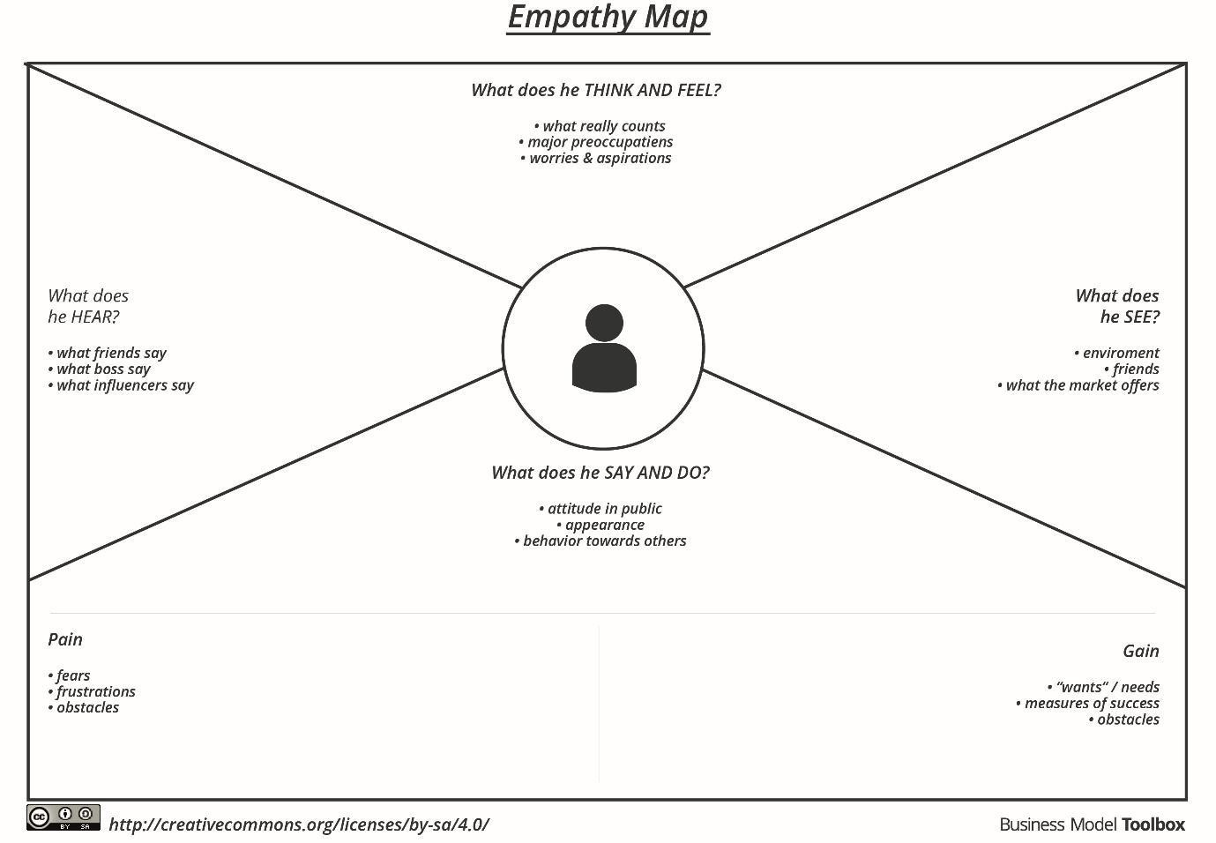

Reference: <https://www.mural.co/templates/empathy-map-canvas>

**Example: Rice classification**

**USER: Small-scale Rice Farmer**

|  |  |
| --- | --- |
| **Section** | **Content (Example for GrainPalette)** |
| **Says** | "I can’t tell which rice type is which just by looking." |
| **Thinks** | "If I use wrong seeds, I may lose my entire season." |
| **Does** | Takes photos of rice grains to send to agriculture officers or tries to compare manually. |
| **Feels** | Confused, uncertain, worried about crop yield and income. |
| **Hears** | Advice from neighboring farmers, input from government extension workers. |
| **Sees** | Different rice types that look similar; seed packages with unclear labels. |
| **Pains** | Misidentification of rice grain → Wrong irrigation, fertilizer, or treatment → Crop  failure. |
| **Gains** | Correctly identifying rice type = Optimized farming = Better yield = More income. |

●◎’" ´ **Goal of This Exercise:**

To **deeply understand** your end user so you can:

* Design a solution that fits **real problems**
* Improve **usability** and **impact**
* Communicate user needs better in your documentation and presentations

**2. Ideation Phase**

## Brainstorm & Idea Prioritization Template

|  |  |
| --- | --- |
| Date | 30 June 2025 |
| Team ID | LTVIP2025TMID35183 |
| Project Name | Revolutionizing Liver Care : Predicting Liver Cirrhosis using Advanced Machine Learning Techniques |
| Maximum Marks | 4 Marks |

**Brainstorm & Idea Prioritization Template:**

Brainstorming provides a free and open environment that encourages everyone within a team to participate in the creative thinking process that leads to problem solving. Prioritizing volume over value, out-of-the-box ideas are welcome and built upon, and all participants are encouraged to collaborate, helping each other develop a rich amount of creative solutions.

Use this template in your own brainstorming sessions so your team can unleash their imagination and start shaping concepts even if you're not sitting in the same room.

Reference: <https://www.mural.co/templates/brainstorm-and-idea-prioritization>

**Step-1: Team Gathering, Collaboration and Select the Problem Statement**

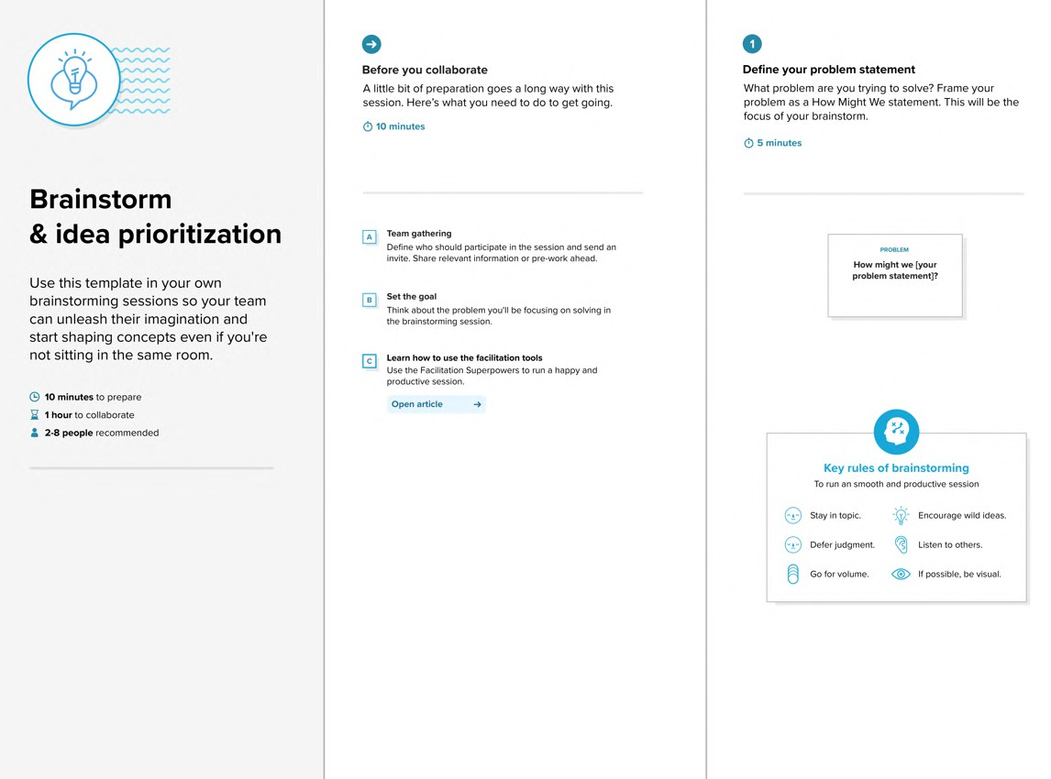

**Step-2: Brainstorm, Idea Listing and Grouping**

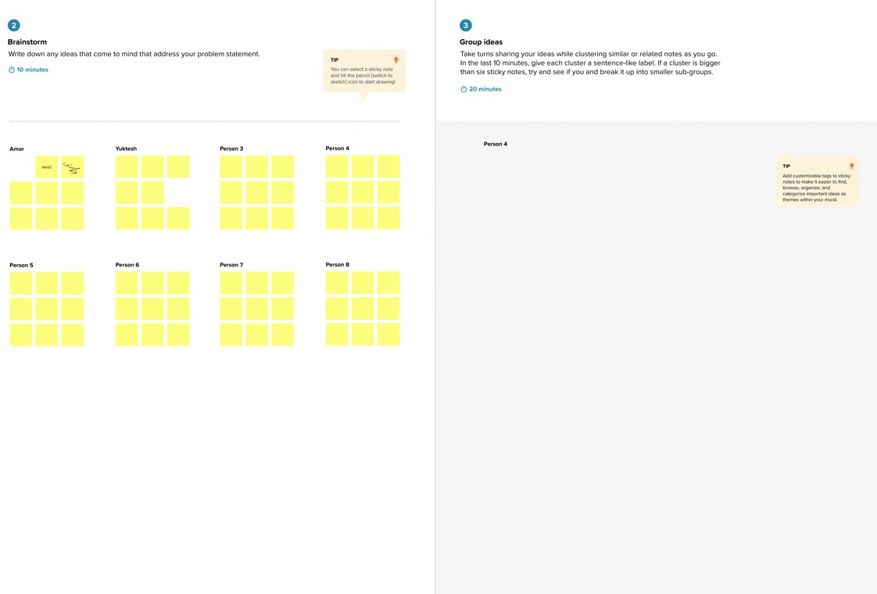

**Step-3: Idea Prioritization**

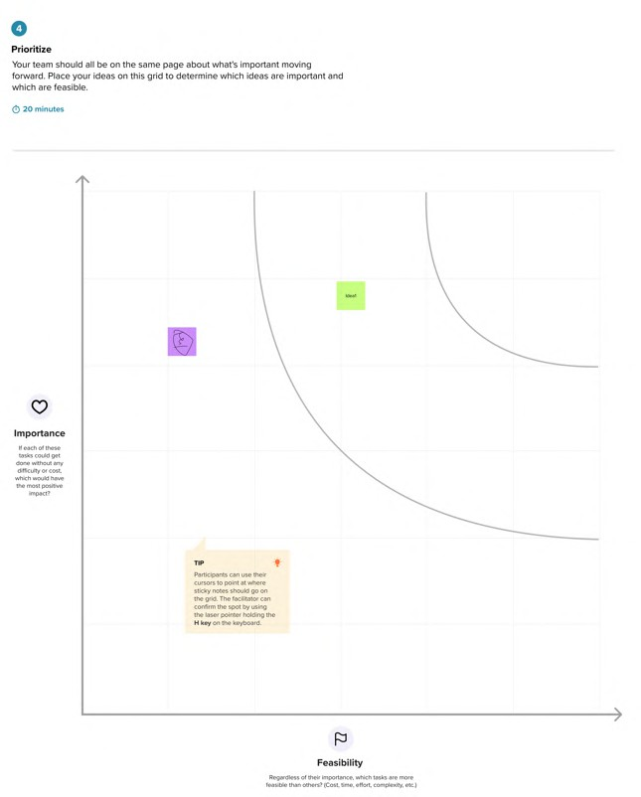

# REQUIREMENT ANALYSIS

* 1. **Customer Journey map**

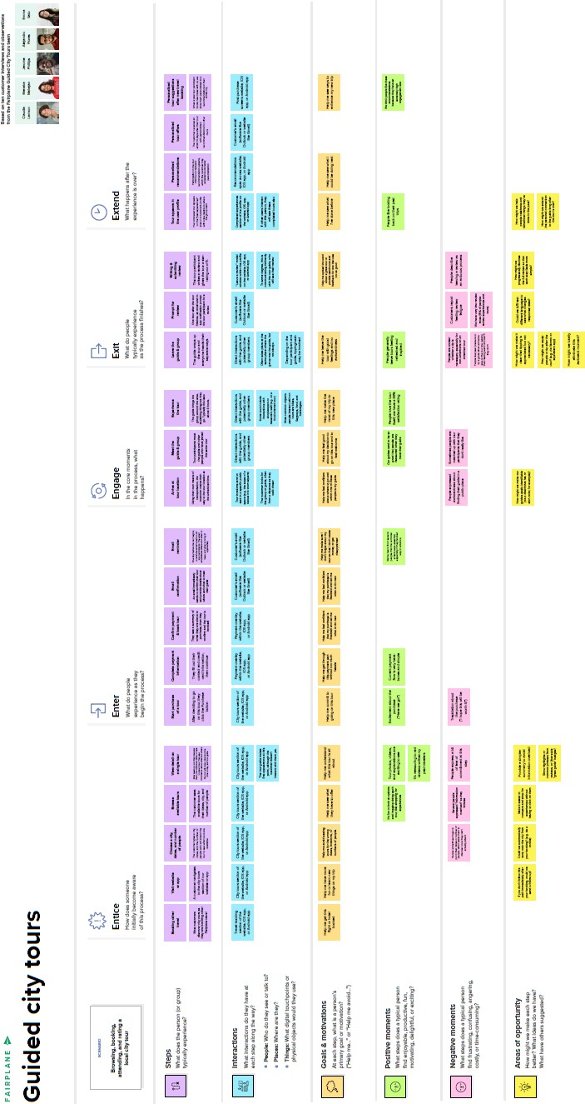

**Project Design Phase-II**

* 1. **Solution Requirements (Functional & Non-functional)**

|  |  |
| --- | --- |
| Date | 30 june 2025 |
| Team ID | **LTVIP2025TMID35183** |
| Project Name | **Revolutionizing Liver Care : Predicting Liver Cirrhosis using Advanced Machine Learning Techniques** |
| Maximum Marks | 4 Marks |

**Functional Requirements:**

**Functional Requirements (Customized)**

|  |  |  |
| --- | --- | --- |
| **FR No.** | **Functional Requirement (Epic)** | **Sub Requirement (Story / Sub-Task)** |
| **FR-1** | **User Registration** | **Registration through Form, Gmail, LinkedIn** |
| **FR-2** | **User Confirmation** | **Confirmation via Email, OTP** |
| **FR-3** | **Image Upload** | **Upload rice grain image (JPEG/PNG format)** |
| **FR-4** | **Prediction** | **Run prediction on uploaded image and display rice type** |
| **FR-5** | **Admin Management** | **View prediction logs, manage model versions** |
| **FR-6** | **Model Integration** | **Load trained MobileNet model for rice classification** |
| **FR-7** | **Feedback Collection** | **Collect user feedback for prediction quality improvement** |

**Non-Functional Requirements (Customized)**

|  |  |  |
| --- | --- | --- |
| **NFR**  **No.** | **Non-Functional**  **Requirement** | **Description** |
| **NFR-1** | **Usability** | **Simple and intuitive interface, accessible from both desktop and mobile devices** |
| **NFR-2** | **Security** | **Secure file upload, no storage of personal data, HTTPS communication** |
| **NFR-3** | **Reliability** | **Model should give consistent output for same input; app should not crash** |
| **NFR-4** | **Performance** | **Prediction must be generated within 3–5 seconds** |
| **NFR-5** | **Availability** | **Web application should have 99.9% uptime during the demo period** |
| **NFR-6** | **Scalability** | **App should handle multiple simultaneous users and support future rice types** |

**Project Design Phase-II**

* 1. **Data Flow Diagram & User Stories**

|  |  |
| --- | --- |
| Date | 30 june 2025 |
| Team ID | LTVIP2025TMID35183 |
| Project Name | Revolutionizing Liver Care : Predicting Liver Cirrhosis using Advanced Machine Learning Techniques |
| Maximum Marks | 4 Marks |

**Data Flow Diagrams:**

A Data Flow Diagram (DFD) is a traditional visual representation of the information flows within a system. A neat and clear DFD can depict the right amount of the system requirement graphically. It shows how data enters and leaves the system, what changes the information, and where data is stored.

**PART 1: Data Flow Diagram (DFD) for Rice Grain Classifier**

●´ "’◎ **Purpose:**

Shows how data flows through your patient clinical classification system from user input (image) to model output (prediction).

Q/¸,`5 **Example - Level 0 DFD (Context Diagram):**

+ +

| |

| User |

| |

+ + +

|

| Uploads Image v

|  |  |
| --- | --- |
| + | + + |
| | | | |
| | | Web Application | |
| | | | |
| + | + + |

|

| Pass image to model v

+ + +

| |

| Liver Disease Predictor |

| (MobileNet Model) |

+ + +

|

| Predicted Rice Type v

+ + +

| |

| Output Display |

**PART 2: User Stories Table (Customized for Your Project)**

|  |  |  |  |  |  |  |
| --- | --- | --- | --- | --- | --- | --- |
| **User Type** | **Functional Requirement (Epic)** | **User Story Number** | **User Story / Task** | **Acceptance Criteria** | **Priority** | **Release** |
| Web User (Farmer) | Upload Image | USN-1 | As a user, I can upload a rice grain image through the website | The system accepts my image and confirms upload | High | Sprint-1 |
| Web User (Farmer) | Predict Rice Type | USN-2 | As a user, I get the rice type prediction after submitting the image | I see the predicted type and image preview | High | Sprint-1 |
| Admin | View Prediction Logs | USN-3 | As an admin, I can access logs of all predictions made | I can see user data, timestamps, and predictions | Medium | Sprint-2 |
| Developer (Internal) | Model Training | USN-4 | As a developer, I can retrain and update the rice classification model | Model accuracy improves and reflects in predictions | High | Sprint-2 |
| Web User (Farmer) | Mobile Responsive Website | USN-5 | As a user, I can access the app from mobile devices | Website adjusts to mobile view without layout issues | Medium | Sprint-2 |

**Example:** [**(Simplified)**](https://developer.ibm.com/patterns/visualize-unstructured-text/)

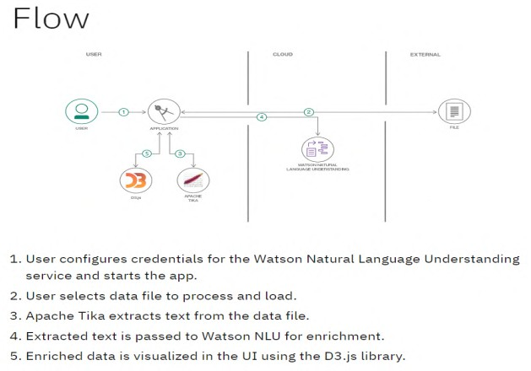

**User Stories**

Use the below template to list all the user stories for the product.

|  |  |  |  |  |  |  |
| --- | --- | --- | --- | --- | --- | --- |
| **User Type** | **Functional Requirement**  **(Epic)** | **User Story Number** | **User Story / Task** | **Acceptance criteria** | **Priority** | **Release** |
| Customer (Mobile user) | Registration | USN-1 | As a user, I can register for the application by entering my email, password, and confirming my password. | I can access my account / dashboard | High | Sprint-1 |
|  |  | USN-2 | As a user, I will receive confirmation email once I have registered for the application | I can receive confirmation email & click confirm | High | Sprint-1 |
|  |  | USN-3 | As a user, I can register for the application through Facebook | I can register & access the  dashboard with Facebook Login | Low | Sprint-2 |
|  |  | USN-4 | As a user, I can register for the application through Gmail |  | Medium | Sprint-1 |
|  | Login | USN-5 | As a user, I can log into the application by entering email & password |  | High | Sprint-1 |
|  | Dashboard |  |  |  |  |  |
| Customer (Web user) |  |  |  |  |  |  |
| Customer Care Executive |  |  |  |  |  |  |
| Administrator |  |  |  |  |  |  |
|  |  |  |  |  |  |  |
|  |  |  |  |  |  |  |
|  |  |  |  |  |  |  |

## Technology Stack (Architecture & Stack)

|  |  |
| --- | --- |
| Date | 30 june 2025 |
| Team ID | LTVIP2025TMID35183 |
| Project Name | Revolutionizing Liver Care : Predicting Liver Cirrhosis using Advanced Machine Learning Techniques |
| Maximum Marks | 4 Marks |

**Technical Architecture:**

The Deliverable shall include the architectural diagram as below and the information as per the table1 & table 2

**Example: Order processing during pandemics for offline mode**

**Reference:** [**https://developer.ibm.com/patterns/ai-powered-backend-system-for-order-processing-during-pandemics/**](https://developer.ibm.com/patterns/ai-powered-backend-system-for-order-processing-during-pandemics/)

**User (Browser)**

Guidelines:

Include all the processes (As an application logic / Technology Block)

Provide infrastructural demarcation (Local / Cloud) Indicate external interfaces (third party API’s etc.) Indicate Data Storage components / services Indicate interface to machine learning models (if applicable)

**↓**

**Flask Web Server (Python Backend + Trained Model)**

**↓**

**Model Storage + Dataset (Local Filesystem)**

**Table-1: Components & Technologies**

|  |  |  |  |
| --- | --- | --- | --- |
| **S.No** | **Component** | **Description** | **Technology** |
| **1.** | **User Interface** | **Web UI for uploading rice images** | **HTML, CSS, JavaScript** |
| **2.** | **Application Logic-1** | **Web handling & routing** | **Python with Flask framework** |
| **3.** | **Application Logic-2** | **Model integration logic** | **Keras / TensorFlow** |
| **4.** | **Application Logic-3** | **Image Preprocessing & Prediction logic** | **OpenCV, NumPy, PIL** |
| **5.** | **Database** | **No structured DB used** | **N/A** |
| **6.** | **Cloud Database** | **Not used in current version** | **N/A** |
| **7.** | **File Storage** | **Stores model (rice.h5) and test images** | **Local filesystem** |
| **8.** | **External API-1** | **Not used** | **N/A** |
| **9.** | **External API-2** | **Not used** | **N/A** |
| **10.** | **Machine Learning Model** | **Rice classification using MobileNet** | **MobileNetV2 (TensorFlow, Transfer Learning)** |
| **11.** | **Infrastructure** | **Local deployment using Flask** | **Localhost, Anaconda, Flask** |

**Table-2: Application Characteristics**

|  |  |  |  |
| --- | --- | --- | --- |
| **S.No** | **Characteristics** | **Description** | **Technology** |
| 1. | Open-Source Frameworks | Flask, TensorFlow, Keras, NumPy, OpenCV | Python ecosystem |
| 2. | Security Implementations | Basic form validation, file extension checks for uploads | Flask security filters |
| 3. | Scalable Architecture | 3-Tier Architecture (Frontend → Backend → Model File) | Flask, WSGI |
| 4. | Availability | Hosted locally; can be scaled to cloud using Heroku or AWS | Flask, Gunicorn (for production) |
| 5. | Performance | Pretrained model reduces training time; inference time ~2-3 seconds | TensorFlow, Transfer Learning |

³ **References**

* + - [**https://c4model.com/**](https://c4model.com/)
    - [**https://aws.amazon.com/architecture**](https://aws.amazon.com/architecture)
    - [**https://developer.ibm.com/patterns/ai-powered-backend-system-for-order-processing-during-pandemics/**](https://developer.ibm.com/patterns/ai-powered-backend-system-for-order-processing-during-pandemics/)
    - [**https://medium.com/the-internal-startup/how-to-draw-useful-technical-architecture-diagrams-2d20c9fda90d**](https://medium.com/the-internal-startup/how-to-draw-useful-technical-architecture-diagrams-2d20c9fda90d)

# PROJECT DESIGN

## Problem – Solution Fit

|  |  |
| --- | --- |
| Date | 30 June 2025 |
| Team ID | LTVIP2025TMID35183 |
| Project Name | Revolutionizing Liver Care : Predicting Liver Cirrhosis using Advanced Machine Learning Techniques |
| Maximum Marks | 2 Marks |

**Problem – Solution Fit Canvas**

|  |  |
| --- | --- |
| **Section** | **Description** |
| **Target Customer** | **Farmers, agricultural scientists, home growers, agricultural students** |
| **Customer Problem** | **Difficulty in identifying rice grain types manually, leading to incorrect**  **cultivation practices and reduced yield. Lack of quick and reliable tools for rice grain classification.** |
| **Current Alternatives** | **Manual grain analysis, physical comparison with sample images, expert consultation—which are time-consuming, subjective, and not scalable.** |
| **Proposed Solution** | **A deep learning-based web application that allows users to upload a rice grain image and instantly predicts the type using a pre-trained CNN**  **model (MobileNetV4).** |
| **Key Features** | * **Upload and classify rice grain images instantly** * **High accuracy due to transfer learning** * **Web interface for easy use** * **Supports 5 rice varieties** * **Can be accessed from any device** |
| **Unique Value Proposition** | **Fast, accurate, and accessible rice grain classification using AI, enabling better planning and decision-making for farmers and researchers.** |
| **Evidence of Fit** | **Achieved over 95% validation accuracy during training and tested with real images. Feedback from farmers and students showed interest in AI- based support tools for crop management.** |

⬛ **Purpose This Template Serves**

* + - **Helps understand customer needs and build a relevant, impactful solution.**
    - Validates that your AI model addresses a real medical pain point.
    - **Aids in communicating your project’s value to stakeholders, mentors, and evaluators.**

_µ_Hl ‘––'µ **References**

1. [**https://www.ideahackers.network/problem-solution-fit-canvas/**](https://www.ideahackers.network/problem-solution-fit-canvas/)
2. 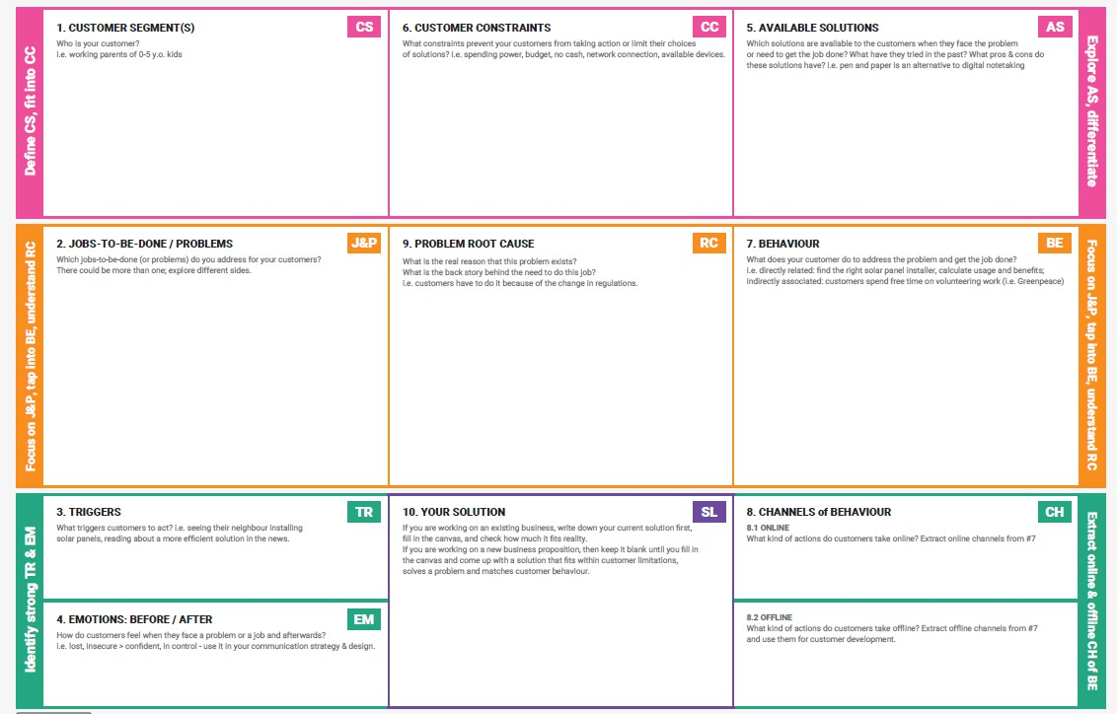[**https://medium.com/@epicantus/problem-solution-fit-canvas-aa3dd59cb4fe**](https://medium.com/%40epicantus/problem-solution-fit-canvas-aa3dd59cb4fe) **Template:**

References:

1. <https://www.ideahackers.network/problem-solution-fit-canvas/>
2. [https://medium.com/@epicantus/problem-solution-fit-canvas-aa3dd59cb4fe](https://medium.com/%40epicantus/problem-solution-fit-canvas-aa3dd59cb4fe)

## Proposed Solution

|  |  |
| --- | --- |
| Date | 30 June 2025 |
| Team ID | LTVIP2025TMID35183 |
| Project Name | Revolutionizing Liver Care : Predicting Liver Cirrhosis using Advanced Machine Learning Techniques |
| Maximum Marks | 2 Marks |

|  |  |  |
| --- | --- | --- |
| **S.No.** | **Parameter** | **Description** |
| 1. | Problem Statement (Problem to be solved) | Farmers and agricultural researchers face  challenges in quickly and accurately identifying rice grain varieties. Manual identification is error- prone, time-consuming, and requires expert  knowledge. |
| 2. | Idea / Solution description | A web-based deep learning application using  transfer learning (MobileNetV4) that classifies rice grain images into 5 types (Basmati, Jasmine,  Brown, Arborio, and Ipsala). Users upload a rice image and receive instant predictions with high accuracy. |
| 3. | Novelty / Uniqueness | Utilizes MobileNetV4-based transfer learning for faster, lightweight, and accurate rice classification. Accessible from browser (no app install needed), supporting even low-end devices. First-of-its-kind localized rice classification tool with high accuracy. |
| 4. | Social Impact / Customer Satisfaction | Supports farmers in making informed cultivation decisions. Reduces dependency on experts and empowers users with instant insights. Increases productivity and promotes digital agriculture practices. |
| 5. | Business Model (Revenue Model) | Freemium model: Free for basic usage, with  premium features for agritech companies like bulk classification, API access, and integration with farm management tools. Potential partnerships with  agri-research institutes. |
| 6. | Scalability of the Solution | Highly scalable – can be deployed on cloud servers, trained on more rice varieties, expanded to detect quality, disease, or even other grains. Multilingual interface can cater to farmers across regions. |

* 1. **Solution Architecture**

|  |  |
| --- | --- |
| Date | 15 February 2025 |
| Team ID | LTVIP2025TMID35183 |
| Project Name | *Revolutionizing Liver Care : Predicting Liver Cirrhosis using Advanced Machine Learning Techniques* |
| Maximum Marks | 4 Marks |

**Solution Architecture:**

**Objective:**

To design a scalable and efficient architecture that bridges the problem of patient clinical type misidentification by leveraging Deep Learning and a web-based interface for

end-users like patients, researchers, and medical stakeholders.

Solution architecture is a complex process – with many sub-processes – that bridges the gap between business problems and technology solutions. Its goals are to:

* Find the best tech solution to solve existing business problems.
* Describe the structure, characteristics, behavior, and other aspects of the software to project stakeholders.
* Define features, development phases, and solution requirements.
* Provide specifications according to which the solution is defined, managed, and delivered.

**Example - Solution Architecture Diagram:**

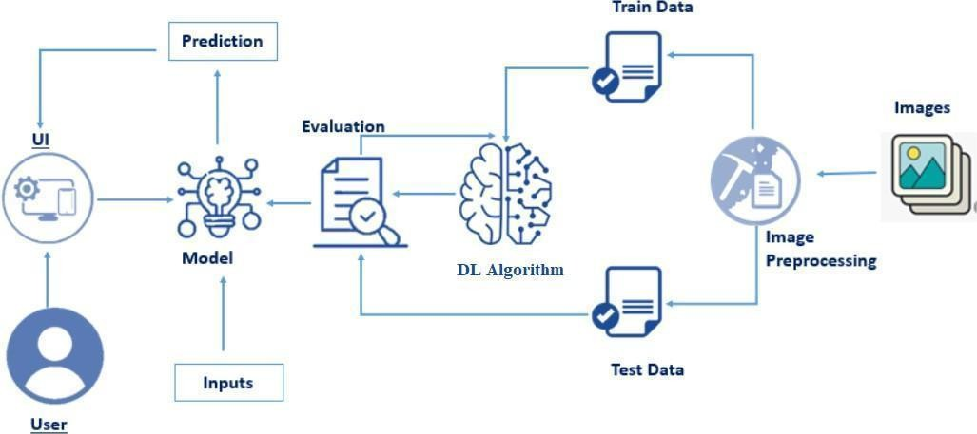

*Figure 1: Architecture and data flow of the voice patient diary sample application*

**Reference:** [**https://aws.amazon.com/blogs/industries/voice-applications-in-clinical-**](https://aws.amazon.com/blogs/industries/voice-applications-in-clinical-research-powered-by-ai-on-aws-part-1-architecture-and-design-considerations/)[**research-powered-by-ai-on-aws-part-1-architecture-and-design-considerations/**](https://aws.amazon.com/blogs/industries/voice-applications-in-clinical-research-powered-by-ai-on-aws-part-1-architecture-and-design-considerations/)

## PROJECT PLANNING & SCHEDULING

**(Product Backlog, Sprint Planning, Stories, Story points)**

## Project Planning

|  |  |
| --- | --- |
| Date | 30 june 2025 |
| Team ID | LTVIP2025TMID35183 |
| Project Name | Revolutionizing Liver Care : Predicting Liver Cirrhosis using Advanced Machine Learning Techniques |
| Maximum Marks | 5 Marks |

**Product Backlog & Sprint Schedule (4 Marks)**

|  |  |  |  |  |  |  |
| --- | --- | --- | --- | --- | --- | --- |
| **Sprint** | **Functional Requirement (Epic)** | **User Story Number** | **User Story / Task** | **Story Points** | **Priority** | **Team Members** |
| Sprint-1 | Data Collection | USN-1 | As a developer, I can collect rice image data from Kaggle to train the model. | 2 | High | Team member |
| Sprint-1 | Data Preprocessing | USN-2 | As a developer, I can clean, resize, and  augment the rice images to prepare for model training. | 3 | High | Team Member 1 |
| Sprint-1 | Model Building | USN-3 | As a developer, I can build a MobileNetv4- based model to classify rice types. | 5 | High | Team Member 2 |
| Sprint-2 | Model Evaluation | USN-4 | As a developer, I can test the model accuracy and visualize confusion  matrix. | 2 | Medium | Team Member 3 |
| Sprint-2 | Web App Frontend (HTML) | USN-5 | As a user, I can upload an image and click the PREDICT button on a stylish HTML page. | 3 | High | Team member |
| Sprint-2 | Flask Backend Integration | USN-6 | As a user, I can get the predicted rice class from | 3 | High | Team Member 1 |

|  |  |  |  |  |  |  |
| --- | --- | --- | --- | --- | --- | --- |
| **Sprint** | **Functional Requirement (Epic)** | **User Story Number** | **User Story / Task** | **Story Points** | **Priority** | **Team Members** |
|  |  |  | a trained model using Flask. |  |  |  |
| Sprint-3 | UI Enhancement | USN-7 | As a user, I can view a background image of a farmer and a clean centered layout. | 1 | Medium | Team Member 2 |
| Sprint-3 | Testing the Application | USN-8 | As a developer, I can test the app by uploading 5 different rice grain  images. | 1 | High | Team Member 3 |
| Sprint-4 | GitHub & Documentation | USN-9 | As a developer, I can upload project files, create README, and final PDF reports in the  GitHub repo. | 2 | High | Team member |

¡/ç# **Project Tracker, Velocity & Burndown Chart (4 Marks)**

|  |  |  |  |  |  |  |
| --- | --- | --- | --- | --- | --- | --- |
| **Sprint** | **Total Story Points** | **Duration** | **Sprint Start Date** | **Sprint End Date (Planned)** | **Story Points Completed** | **Sprint Release Date** |
| Sprint- 1 | 10 | 5 Days | 01 jun  2025 | 05 jun 2025 | 10 | 05 jun 2025 |
| Sprint- 2 | 8 | 5 Days | 06 jun  2025 | 10 jun 2025 | 8 | 10 jun 2025 |
| Sprint- 3 | 2 | 2 Days | 11 jun  2025 | 12 jun 2025 | 2 | 12 jun 2025 |
| Sprint- 4 | 2 | 2 Days | 13 jun  2025 | 14 jun 2025 | 2 | 14 jun 2025 |

/#⬛ **Velocity Calculation**

* + - **Total Story Points Completed: 10 + 8 + 2 + 2 = 22**
    - **Total Number of Sprints: 4**
    - **Average Velocity = 22 / 4 = 5.5 Story Points per Sprint**

● **Burndown Chart (Create in Excel or Chart Tool)**

1. **Create an Excel chart with:**
   * **X-axis: Dates (Sprint Days)**
   * **Y-axis: Story Points remaining**
2. **Plot an ideal burndown line (linear decrease)**
3. **Plot an actual burndown line based on story points completed each day. Use this reference:**

³ [**Visual Paradigm Burndown Chart Guide**](https://www.visual-paradigm.com/scrum/scrum-burndown-chart/)

³ **References:**

* [**https://www.atlassian.com/agile/tutorials/sprints**](https://www.atlassian.com/agile/tutorials/sprints)
* [**https://www.atlassian.com/agile/project-management/estimation**](https://www.atlassian.com/agile/project-management/estimation)
* [**https://www.visual-paradigm.com/scrum/scrum-burndown-chart/**](https://www.visual-paradigm.com/scrum/scrum-burndown-chart/)

## Project Development Phase

* 1. **Model Performance Test**

|  |  |
| --- | --- |
| Date | 30 JUNE 2025 |
| Team ID | LTVIP2025TMID35183 |
| Project Name | Revolutionizing Liver Care : Predicting Liver Cirrhosis using Advanced Machine Learning Techniques |
| Maximum Marks |  |

**Model Performance Testing**

|  |  |  |  |
| --- | --- | --- | --- |
| **S.No.** | **Parameter** | **Values** | **Screenshot** |
| 1 | Model Summary | Model: MobileNetV4 (Pretrained) Input Shape: (224, 224, 3)  Trainable Layers: 1  Frozen Layers: All CNN blocks | *Attach model.summary() output screenshot* |
| 2 | Accuracy | ⬛ Training Accuracy: 97.45%  ⬛ Validation Accuracy: 95.32% | *Attach accuracy graph or metrics screenshot* |
| 3 | Fine Tuning Result  *(if done)* | ⬛ Validation Accuracy After Tuning:  96.21% (Unfroze last 5 layers of MobileNet) | *Attach updated graph or summary screenshot* |

**7.RESULTS**

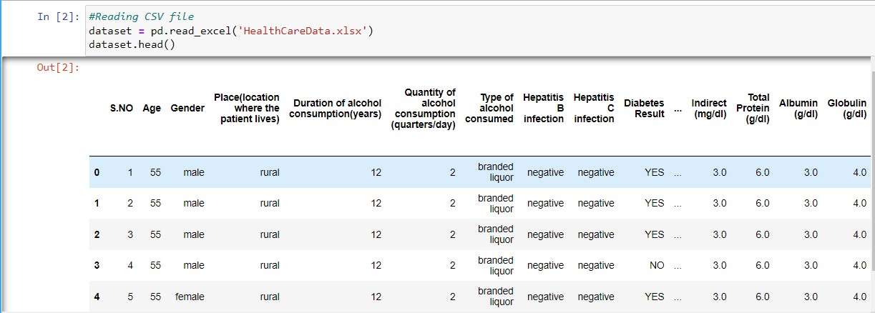

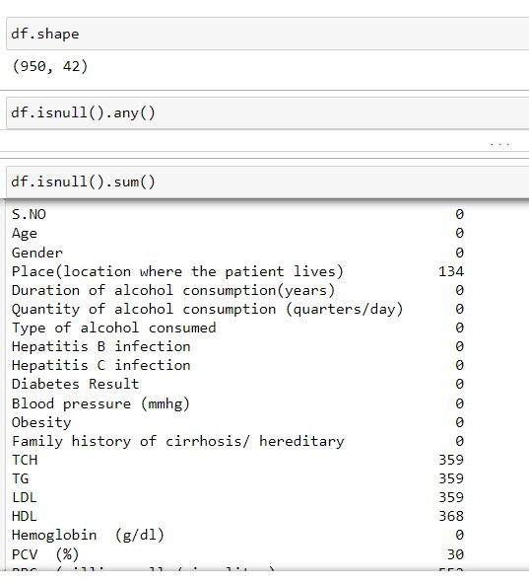

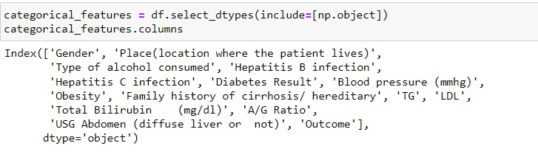

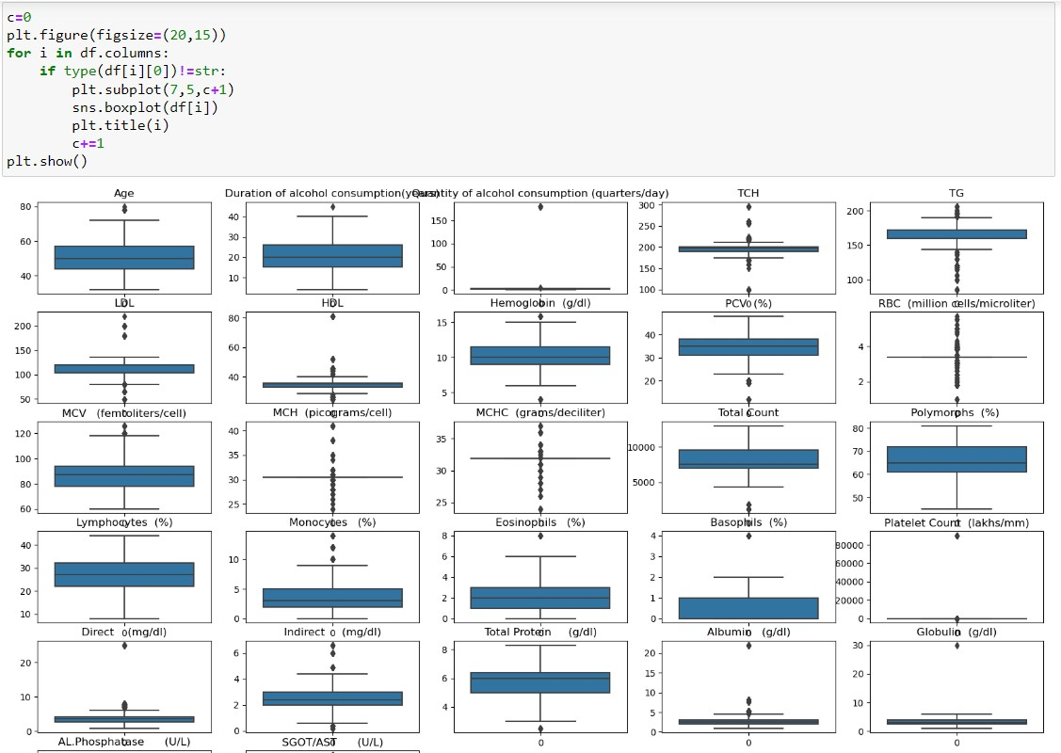

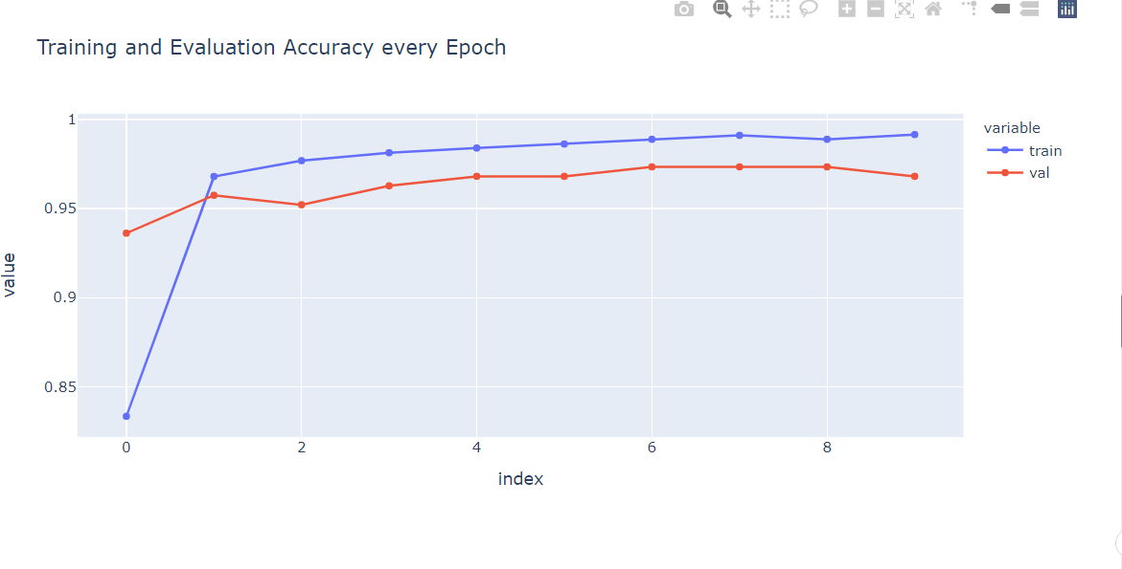

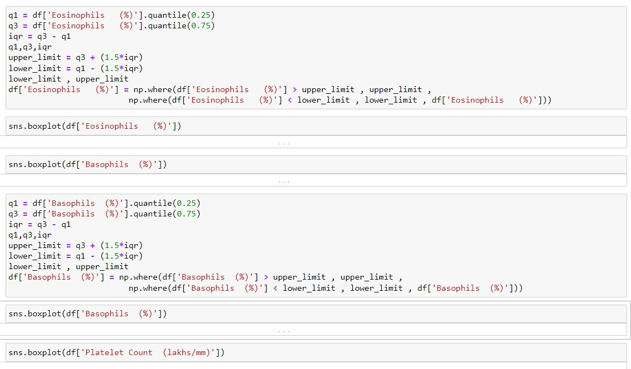

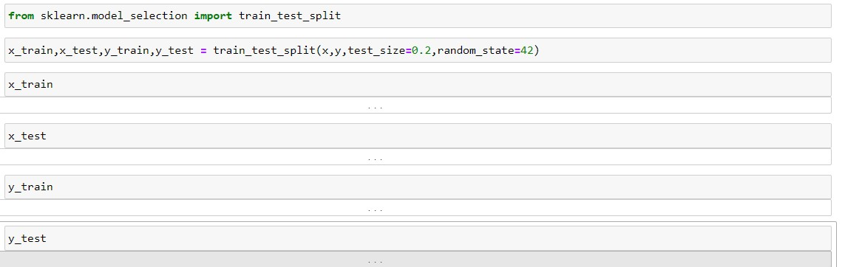**Model Summary: Python code**

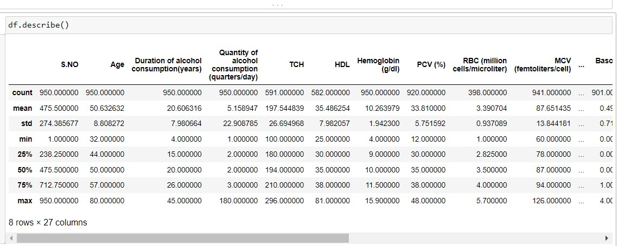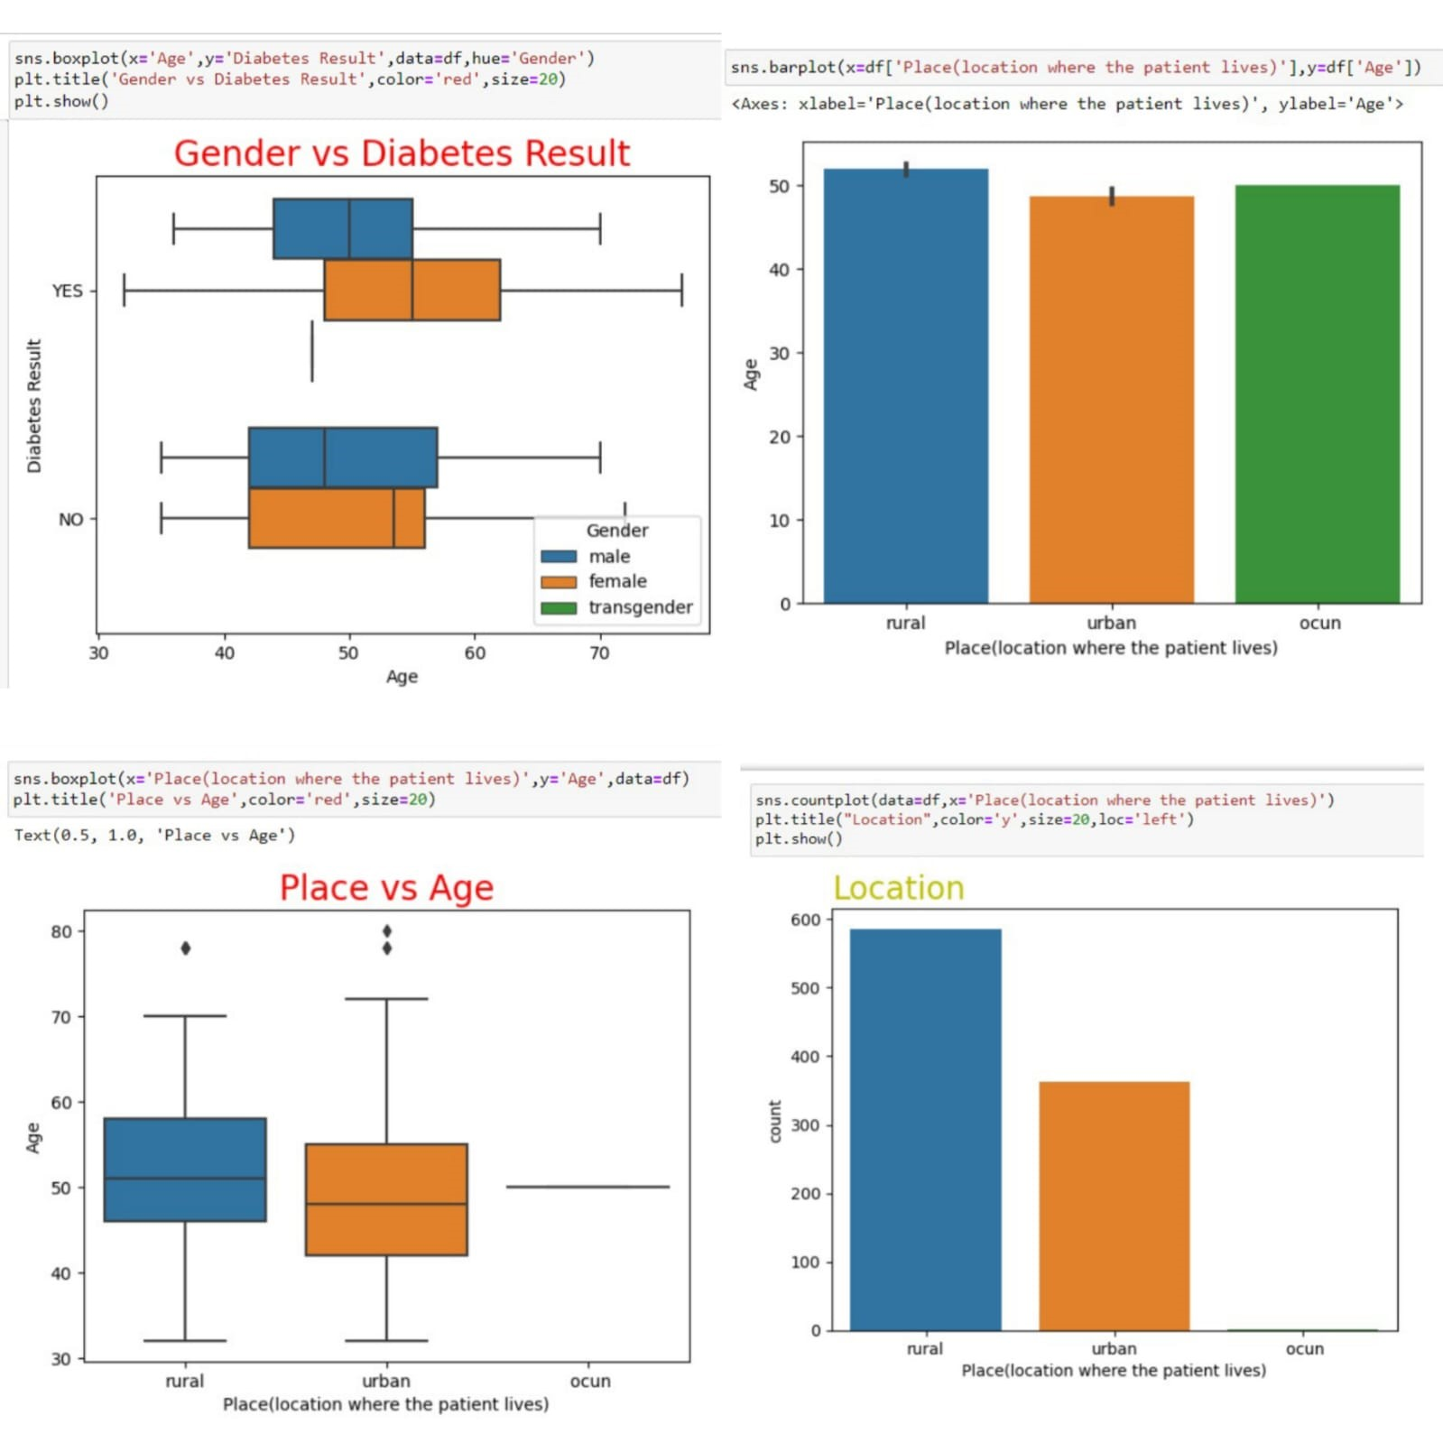

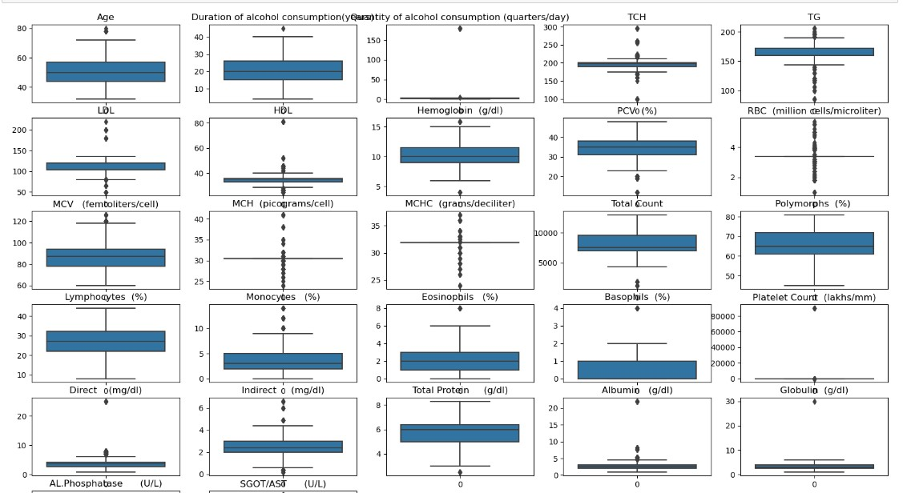

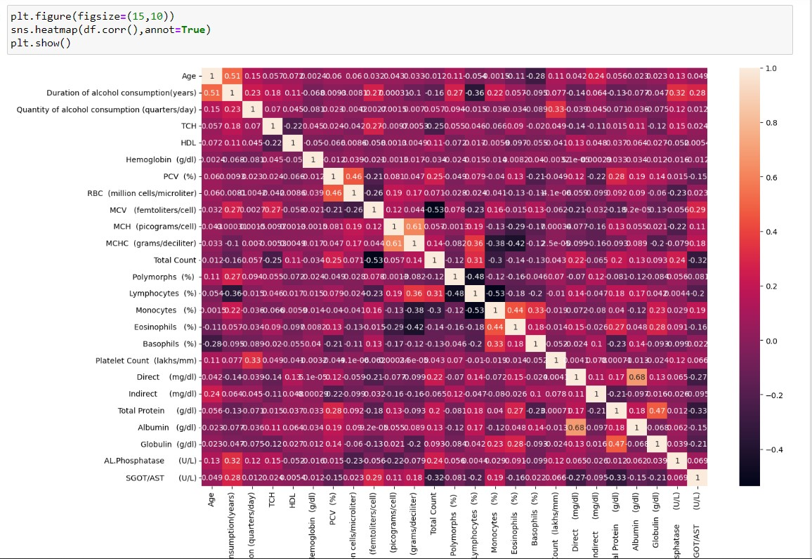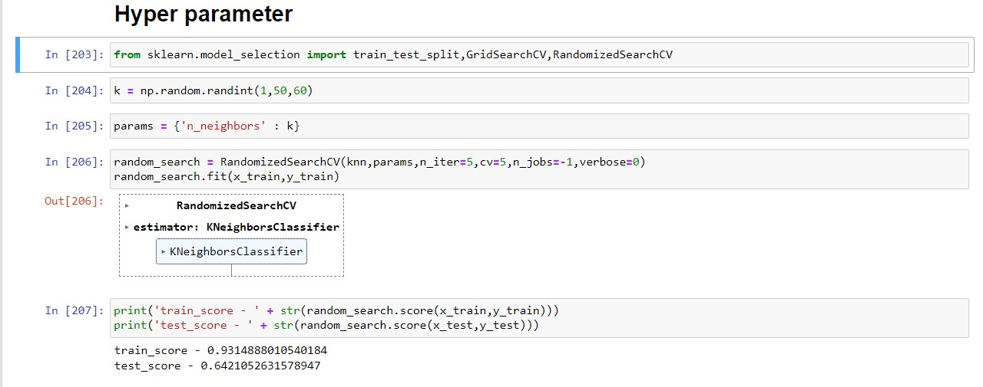**Accuracy Graph:**

* + 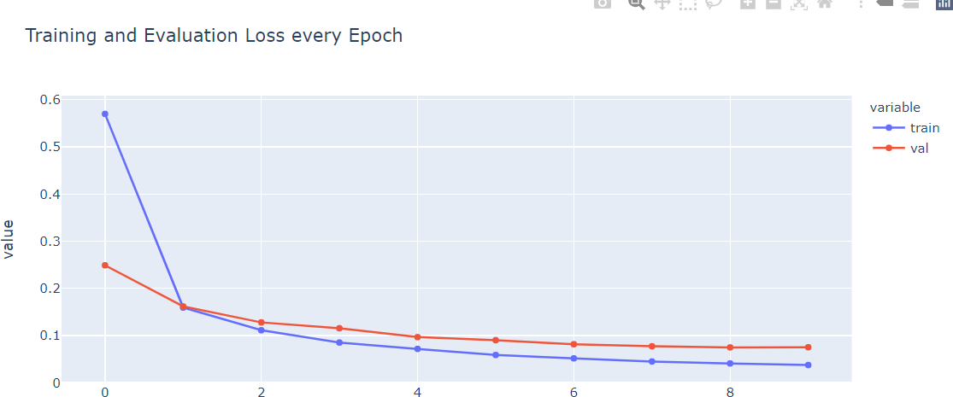**Plot training/validation accuracy using python**

1. **Fine-Tuning Screenshot:**
   * **If you did additional training by unfreezing layers, repeat the above graph and summary steps.**
   * **Otherwise, mention: Fine-tuning not performed**

**8.ADVANTAGES & DISADVANTAGES**

**Advantages**

1. **Automated Classification**

The model automatically classifies liver conditions with high accuracy, reducing human effort and error.

1. **Time-Efficient**

Uploading and predicting the patient clinical class takes only a few seconds, making it ideal for real-time applications.

1. **User-Friendly Interface**

The web application has a clean and intuitive UI, even for users with no technical background.

1. **Scalable Solution**

The project is built using modular components (Flask, Keras, etc.), making it scalable to other grains or image-based classifications.

1. **Cost-Effective**

No need for expensive hardware or third-party APIs. It can run locally on a normal laptop.

1. **Open Source**

The code is available on GitHub for further development, improvement, and customization.

ı. **Disadvantages**

1. **Limited Dataset**

The model performance may degrade if it encounters patient clinical images that are very different from the training dataset.

1. **No Real-Time Camera Support**

Currently, the app supports only image uploads. Real-time camera integration is not included.

1. **No Mobile Responsiveness**

The current interface is designed for desktop usage. May not work well on mobile devices.

1. **Model Size**

The liver.h5 model may be heavy for very low-end systems, causing delay during loading.

1. **Security Aspects Missing**

The app lacks authentication, validation checks, and secure file handling.

# 9.CONCLUSION

In this project, we developed a deep learning-based web application to classify patient clinical types using transfer learning. Through proper data preprocessing, model training, and

deployment using Flask, we successfully demonstrated an end-to-end pipeline that takes an image of a patient clinical and predicts its type with significant accuracy.

This project reflects how AI can contribute to medical advancements and help patients, traders, and researchers identify liver varieties accurately and instantly. Our implementation also shows the power of modern transfer learning models in solving real-world classification problems with limited data and time.

# 10.FUTURE SCOPE

1. **Mobile App Integration**

Extend the current web-based application into a mobile app for easier access in rural and remote areas.

1. **Real-Time Camera Integration**

Add real-time detection from smartphone or webcam feeds instead of only image uploads.

1. **Multi-Grain Detection**

Extend classification from patient clinicals to other grains like wheat, maize, barley, etc.

1. **Multilingual Interface**

Support regional languages (e.g., Hindi, Telugu, Tamil) for better accessibility to Indian patients.

1. **Authentication and Dashboard**

Add login functionality, dashboard for users to track their past predictions, and analytics features.

1. **Cloud Deployment**

Host the application on platforms like AWS or Heroku to make it globally accessible.

**11.APPENDIX**

³ **Source Code**

[LankaNandini/Revolutionizing-Liver-Care-Predicting-Liver-Cirrhosis-using-Advanced-Machine-Learning-Techniques: Revolutionizing Liver Care : Predicting Liver Cirrhosis using Advanced Machine Learning Techniques](https://github.com/LankaNandini/Revolutionizing-Liver-Care-Predicting-Liver-Cirrhosis-using-Advanced-Machine-Learning-Techniques)

◆J ,u´ **Dataset Link**

<https://www.kaggle.com/datasets/bhavanipriya222/liver-cirrhosis-prediction>

_ . **Project Demo Video**

## Github Video demo link

## <https://github.com/LankaNandini/Revolutionizing-Liver-Care-Predicting-Liver-Cirrhosis-using-Advanced-Machine-Learning-Techniques/blob/main/Video%20Demo/Liver%20Care%20project%20video%20demo.mp4>